**Introduction:**

This document briefly outlines my key achievements in support of NIV application.

**Evidence 1:**

First evidence covers my PhD project research activities and my contributions to the research work. My research project was to address the question of how the diverse cellular environment known as macromolecular crowding changes the rate of biochemical reactions occurring in the cells and how we can construct the realistic environment in computer simulations rather than using the approximated analytical models to compute the reaction rates.

Traditionally, chemists/biochemists perform chemical experiments in dilute solutions containing only reacting species or compounds. The test tube environment does not reflect the real cellular environment, which is found to be one of the key contributing factors to obtain the maximum yield in experiments.

To answer this question, we introduced a new idea and developed a framework that computes the macromolecular crowding on chemical reactions. This framework is applicable to various reactions, but we used it to study the protein folding process. Our framework consists of three parts, Monte Carlo simulation (experimental model), extended-scale particle theory (analytical model), and transition state theory (kinetic model) to calculate the folding rate and structure stability.

Below is the link to thesis available in the University of Lethbridge's dissertation repository for project details and source code.

Thesis Link: <https://hdl.handle.net/10133/4900>

**Evidence 2:**

This evidence pertains to a project called "Customer Complaints, Data Cleansing, and Validation" to demonstrate how I made a significant technical contribution and had a huge impact in my workplace. The project was endorsed by the entire organization where I went above and beyond my job responsibilities on this project.

There was a backlog of customer complaints that was built up over several months. This impacted the departmental KPIs, interdepartmental relationships, and delayed the delivery of quality continuous improvement programs. The underlying problems were the small-sized quality team, inadequate system design to accommodate tremendous business growth, and labor-intensive work of data collection and cleansing.

Our historical data showed that 2500-3000 complaints were received per month from across Canada which required the quality team to spend an entire day catching up with the complaint receiving, reviewing, cleansing, and routing process, leaving no time to deal with other tasks. The constant influx of complaints, and the repetitive and time-consuming nature of the work resulted in a massive backlog.

I took steps to understand the process and identify possibilities for automation to maintain the service standards. I developed an application in Python to automate the tasks related to data cleansing, routing and information processing. Time profile analysis showed that the program performed these tasks in a fraction of seconds, and quality team was able to complete their full day's work of cleansing in a matter of few minutes.

My team was able to clear the backlog of complaints in two weeks, that had built up over the past 10 months. It was a moment of achievement for all of us when we announced that the backlog was finally complete and eliminate the need of hiring new staff, result in saving significant amount of money in the long run.

The following link leads to source code and screenshots of email showcase the endorsement by senior management.

Source Code: [NIV/Complaint Management Source Code.py at main · msajidiqbal/NIV](https://github.com/msajidiqbal/NIV/blob/main/Complaint%20Management%20Source%20Code.py)

Figure 1. Depicts the number of complaints received on a daily basis and number of corrections require before notifying the vendors.

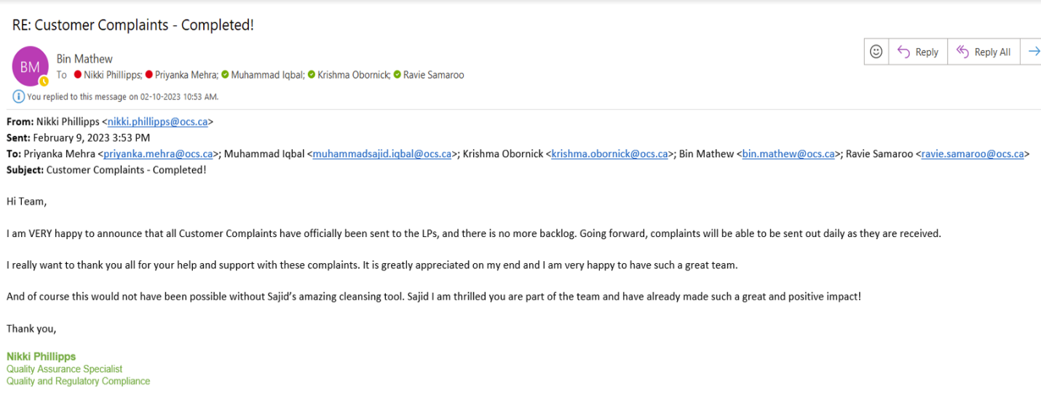

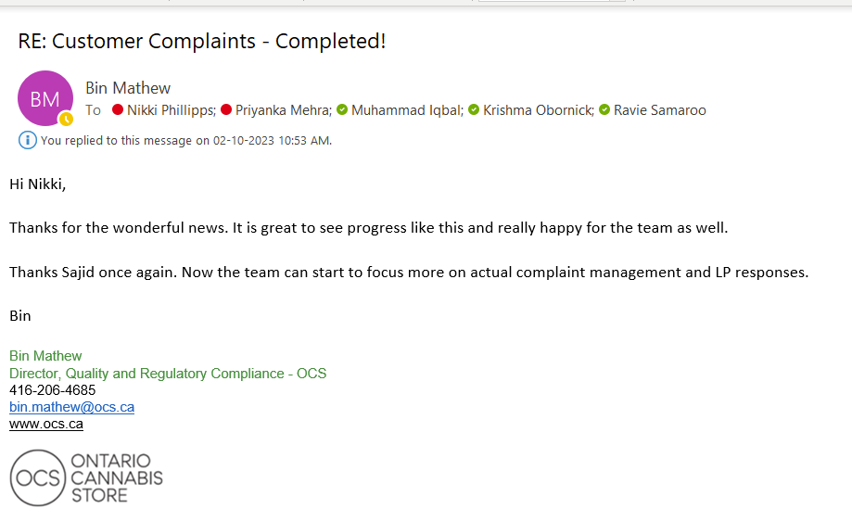

**Evidence 3:**

This project covers the activities related to the development and deployment of a Vendor Compliance Management system to handle vendor’s non-conformity records. The application was built in Microsoft Power Apps and provides the approval workflow, sends emails to suppliers, collects supplier responses, and manages the users and suppliers.

Warehouse Quality Operations team is responsible for receiving, inspecting and releasing products to provincial retailers. The quality operation team relayed on email correspondence to communicate with vendors about non-conformances and does not have a central repository to store documents, vendor reports, and a database to perform tracking and identify trends to make recommendations to supply chain and business, and planning teams.

To address these issues, I proposed and developed a solution that provides an efficient way to do record management, capture vendor communication in a centralized system without incurring extra costs to the department. This application helps teams to export data for further analysis, and help new employees to learn the process from the program by reviewing the historical cases.

The following screenshot depicts the main screen of the Supplier Nonconformance Records Management application. This is a sandbox environment to respect the client's confidential information. The application added significant value to the business and other departments working with the quality unit. Many teams migrated from Microsoft Excel sheets to the system to manage suppliers, retrieve and view incidents.

Source Code: [NIV/VendorManagement_20230823132118.zip at main · msajidiqbal/NIV](https://github.com/msajidiqbal/NIV/blob/main/VendorManagement_20230823132118.zip)

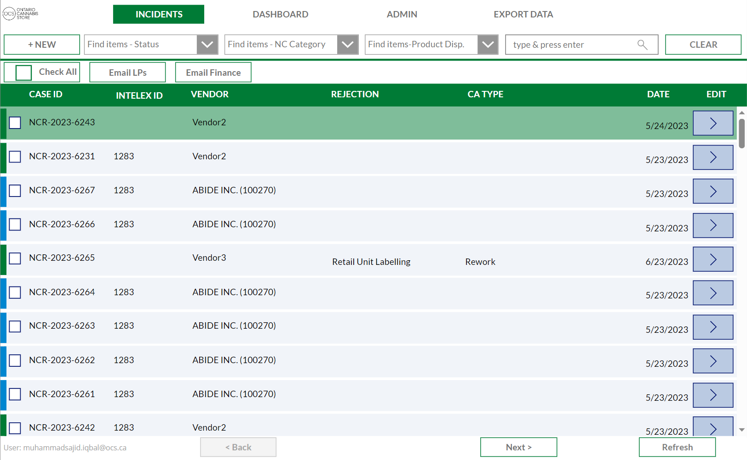

Figure 1. Home Screen of Vendor Compliance Management Application